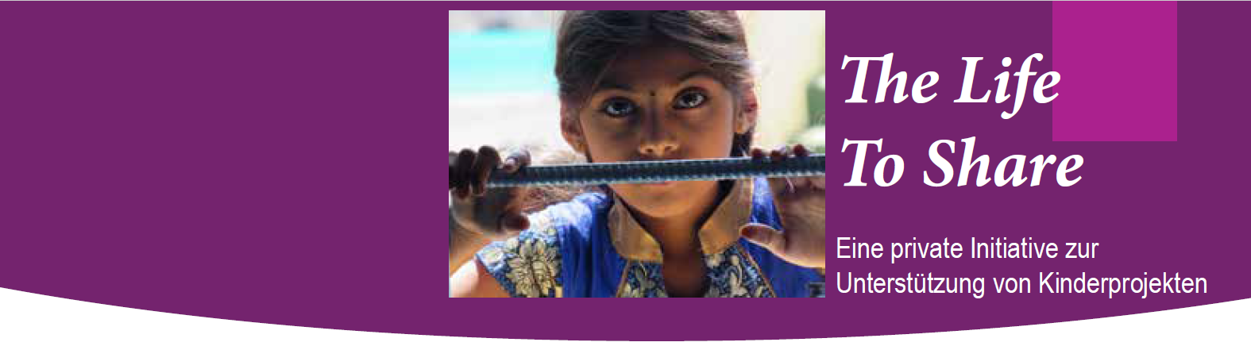

_________________________________________________________
The Life to Share, Hartmut Bannert, c/o ALLERGIKA Pharma GmbH, Hans-Urmiller-Ring 58, 82515 Wolfratshausen
Email: info@thelifetoshare.com – Internet: www.thelifetoshare.com
Tel.: 08171 / 4225-920 – Fax : 08171 / 4225 – 852

Spendenkonto : Liga Bank;
Empfänger: Missio;
Konto: 55279-798, Bannert/Khammam;
IBAN: DE96 750 90 3000 8000 8000 4
BIC: GENODEF1M05

